**Dataset-1: India .csv: 12**

Topic-1: Vaccine inequity

|  |  |
| --- | --- |
| **Probability** | **FREX** |
|  |  |
| vaccin, countri, unit, world, covid-, peopl, global, million, health, billion | unit, apartheid, poor, rich, infect, restrict, death, variant, wealthi, human |

Topic-2: Vaccine Strategy: Multilateral Perspectives

|  |  |
| --- | --- |
| **Probability** | **FREX** |
|  |  |
| nation, countri, activ, polit, region, local, initi, econom, develop, among | nation, activ, local, strateg, combat, believ, rapid, implic, civil, societi |

Topic-3: Vaccine Diplomacy Context: Bangladesh

|  |  |
| --- | --- |
| **Probability** | **FREX** |
|  |  |
| bangladesh, vaccin, india, dose, dhaka, minist, million, said, hasina, countri | hasina, sheikh, dhaka, momen, prime, bangladesh’, sign, minist, gift, bangladesh |

Topic-4: Vaccine Diplomacy Context: Russia-China

|  |  |
| --- | --- |
| **Probability** | **FREX** |
|  |  |
| vaccin, china, countri, chines, russia, diplomaci, china’, power, sputnik, health | balkan, china’, central, geopolit, sputnik, russia, bri, road, russia’, chines |

Topic-5: Vaccine Diplomacy Context: Bangladesh

|  |  |
| --- | --- |
| **Probability** | **FREX** |
|  |  |
| vaccin, dose, bangladesh, million, countri, covax, govern, covid-, peopl, health | crore, lakh, covax, administ, receiv, stock, target, programm, general, percent |

Topic_6: Vaccine Diplomacy Context: Russia-China

|  |  |
| --- | --- |
| **Probability** | **FREX** |
|  |  |
| vaccin, countri, global, new, read, covid-, power, region, rivalri, russia | read, rivalri, citizenship, undermin, taiwan, law, epidem, tension, cast, status |

Topic-7: Vaccine Economy

|  |  |
| --- | --- |
| **Probability** | **FREX** |
|  |  |
| vaccin, countri, bangladesh, covid-, eib, will, develop, support, peopl, pandem | eib, oper, session, financ, eib’, team, life, lockdown, friendship, people’ |

Topic-8: Vaccine Economy

|  |  |
| --- | --- |
| **Probability** | **FREX** |
|  |  |
| vaccin, bangladesh, countri, said, china, india, get, will, diplomaci, trial | contact, vaccine-produc, potenti, sourc, procur, due, trial, maintain, strategi, delwar |

Topic-9: Vaccine Diplomacy Context: India

|  |  |
| --- | --- |
| **Probability** | **FREX** |
|  |  |
| india, vaccin, countri, world, pandem, india’, will, bangladesh, diplomaci, foreign | modi, neighbour, goodwil, covid, emot, medic, tradit, medicin, exhibit, foreign |

Topic-10: Vaccine Diplomacy Context: India

|  |  |
| --- | --- |
| **Probability** | **FREX** |
|  |  |
| vaccin, india, countri, china, dose, india’, million, indian, said, south | neighbor, lanka, sri, covishield, india’, nepal, delhi, wave, neighborhood, indian |

Topic-11: Vaccine Economy

|  |  |
| --- | --- |
| **Probability** | **FREX** |
|  |  |
| vaccin, countri, dose, health, compani, covid-, govern, patent, said, also | chile, patent, price, chile’, booster, moderna, compani, licenc, prevent, usd |

Topic-12: Vaccine Governance

|  |  |
| --- | --- |
| **Probability** | **FREX** |
|  |  |
| vaccin, said, countri, develop, global, covid-, access, must, support, intern | sustain, progress, agenda, properti, waiver, intellectu, emphas, must, stress, goal |

Topic-13: Global Health Diplomacy

|  |  |
| --- | --- |
| **Probability** | **FREX** |
|  |  |
| vaccin, countri, covid-, global, world, dose, health, peopl, popul, mani | blake, refuge, banerje, paul, thing, contin, transpar, there, realli, low-incom |

Topic-14: India: Neighbourhood

|  |  |
| --- | --- |
| **Probability** | **FREX** |
|  |  |
| vaccin, countri, india, global, dose, suppli, covid-, million, develop, india’ | maitri, pharmaceut, medicin, generic, “vaccin, seychell, kit, biotech, capac, india’ |

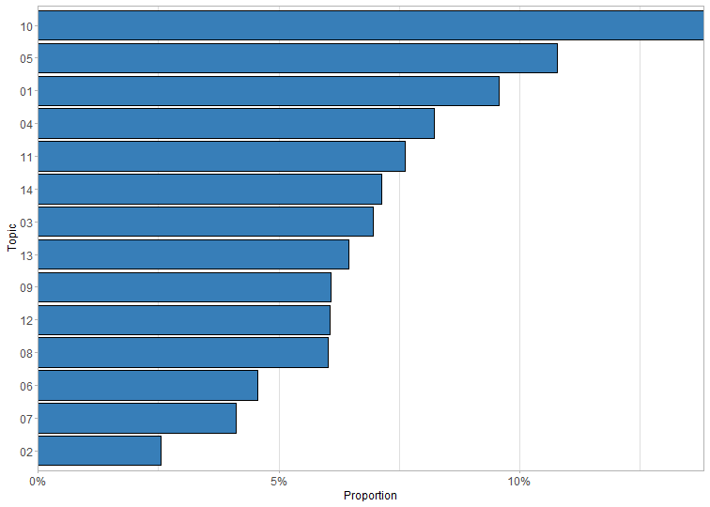

Topic proportion graph

**Topic Proportion Label:**

|  |  |  |
| --- | --- | --- |
| **Topic** | **Label** | **Proportion** |
|  |  |  |
| 1 | 01 | 0.096 |
| 2 | 02 | 0.025 |
| 3 | 03 | 0.070 |
| 4 | 04 | 0.082 |
| 5 | 05 | 0.108 |
| 6 | 06 | 0.046 |
| 7 | 07 | 0.041 |
| 8 | 08 | 0.060 |
| 9 | 09 | 0.061 |
| 10 | 10 | 0.138 |
| 11 | 11 | 0.076 |
| 12 | 12 | 0.061 |
| 13 | 13 | 0.065 |
| 14 | 14 | 0.071 |

**Dataset 2 - Mongolia.csv**

**Topic_1: Vaccine Rollout Strategy**

|  |  |
| --- | --- |
| **Probability** | **FREX** |
|  |  |
| vaccin, mongolia, dose, covid-, will, covax, facil, receiv, first, astrazeneca | astrazeneca, via, facil, covax, pfizer-biontech, april, secretari, unicef, compani, first |

**Topic-2: Vaccine Procurement and Financing**

|  |  |
| --- | --- |
| **Probability** | **FREX** |
|  |  |
| vaccin, mongolia, health, covid-, storag, equip, facil, hospit, support, project | storag, hospit, central, old, equip, children, center, start, store, age |

**Topic-3: Vaccine Procurement and Financing**

|  |  |
| --- | --- |
| **Probability** | **FREX** |
|  |  |
| million, usd, mongolia, covid-, fund, loan, june, govern, arriv, assist | usd, loan, million, fund, june, grant, sign, arriv, agreement, pfizer-comirnati |

**Topic-4: China’s Influence on Mongolia’s Vaccine Response**

|  |  |
| --- | --- |
| **Probability** | **FREX** |
|  |  |
| vaccin, countri, china, chines, china’, diplomaci, covid-, public, state, medic | diplomaci, china’, squar, influenc, relationship, chines, beij, featur, want, nomad |

**TOpic-5: Mongolia’s Social Context**

|  |  |
| --- | --- |
| **Probability** | **FREX** |
|  |  |
| mongolia, econom, countri, covid-, polici, govern, pandem, poverti, per, case | poverti, rate, vision, past, econom, forc, shock, cent, polici, economi |

**Topic-6: Mongolia’s Diversified Vaccine Diplomacy**

|  |  |
| --- | --- |
| **Probability** | **FREX** |
|  |  |
| vaccin, covid-, support, develop, adb, will, mongolia, project, health, access | adb’, adb, apvax, member, pacif, asia, system, project, bank, sustain |

**Topic-7: Russia’s Influence on Mongolia’s Vaccine Response**

|  |  |
| --- | --- |
| **Probability** | **FREX** |
|  |  |
| vaccin, sputnik, countri, mongolia, use, approv, health, develop, sputnik-v, world | sputnik, drug, regist, restrict, efficaci, approv, use, sputnik-v, thousand, russian |

**Topic-8: Mongolia’s Political Context**

|  |  |
| --- | --- |
| **Probability** | **FREX** |
|  |  |
| mongolia, china, vaccin, countri, prime, develop, minist, india, cooper, said | strateg, india, cooper, battsetseg, singh, friend, sincer, neighbor, modi, narendra |

**Topic-9: China’s Influence on Mongolia’s Vaccine Response**

|  |  |
| --- | --- |
| **Probability** | **FREX** |
|  |  |
| vaccin, mongolia, china, mongolian, mongolia’, said, russia, countri, dose, sinopharm | mongolia’, fulli, near, coal, sinopharm, russia, china’, promis, offici, power |

**Topic-10: Mongolia’s Political Context**

|  |  |
| --- | --- |
| **Probability** | **FREX** |
|  |  |
| mongolia, vaccin, ambassador, minist, meet, pandem, develop, covid-, prime, side | ambassador, side, meet, russian, oyun-erden, exchang, extraordinari, plenipotentiari, discuss, attent |

**Topic-11: Mongolia’s Political Context**

|  |  |
| --- | --- |
| **Probability** | **FREX** |
|  |  |
| vaccin, dose, mongolia, receiv, govern, covid-, mongolian, minist, china, sinopharm | flight, dose, verocel, airlin, sinopharm, brought, astrazeneca, miat, april, batch |

**Topic-12: Mongolia benefiting from Global Health Initiatives**

|  |  |
| --- | --- |
| **Probability** | **FREX** |
|  |  |
| vaccin, countri, covid-, develop, health, work, china, meet, mongolia, provid | work, pediatr, mechan, meet, usaid, within, aid, collabor, communiti, conven |

**Topic:13: Mongolia benefiting from Global Health Initiatives**

|  |  |
| --- | --- |
| **Probability** | **FREX** |
|  |  |
| vaccin, mongolia, state, unit, covid-, support, donat, dose, provid, million | unit, state, donat, usaid, effort, agenc, foreign, mongolia’, communic, pfizer |

**Topic-14: Mongolia’s Social Context**

|  |  |
| --- | --- |
| **Probability** | **FREX** |
|  |  |
| vaccin, dose, covid-, third, citizen, mongolia, receiv, peopl, coronavirus, popul | third, death, fourth, citizen, strict, basi, involv, pass, percent, voluntari |

**Topic Proportion graph:**

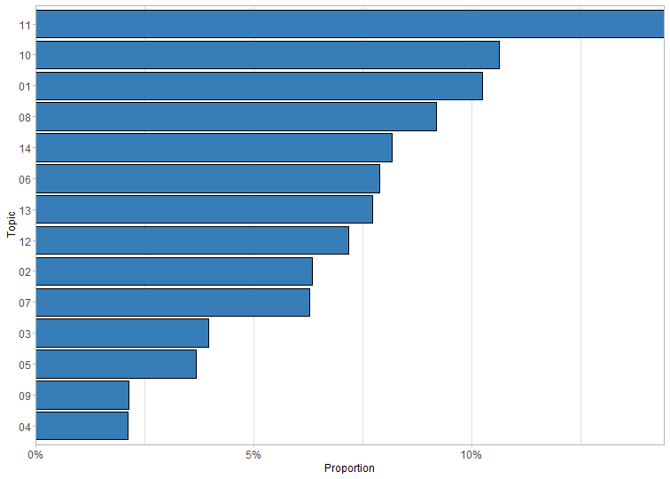

Topic proportion label:

|  |  |  |
| --- | --- | --- |
| **Topic** | **Label** | **Proportion** |
|  |  |  |
| 1 | 01 | 0.102 |
| 2 | 02 | 0.063 |
| 3 | 03 | 0.040 |
| 4 | 04 | 0.021 |
| 5 | 05 | 0.037 |
| 6 | 06 | 0.079 |
| 7 | 07 | 0.063 |
| 8 | 08 | 0.092 |
| 9 | 09 | 0.021 |
| 10 | 10 | 0.106 |
| 11 | 11 | 0.144 |
| 12 | 12 | 0.072 |
| 13 | 13 | 0.077 |
| 14 | 14 | 0.082 |